SYMCA SEM 3

Name:- Roshan Uikey

MCA DIV B

Roll Number:- 2201192

**"A Home for Every Heart : Pet Adoption and Care Center "**

Under the Supervision of

Prof. Apurwa Barwe Ma’am

**1 INTRODUCTION :**

The Animal Adoption and Care Platform is a web-based application designed to facilitate the adoption and care of animals in need, including dogs, cats, and other animals. The platform connects users with registered organizations, allowing them to adopt pets, donate supplies, and offer temporary shelters for injured or recovering animals. This project aims to create a user-friendly and secure platform that promotes responsible pet ownership and animal welfare.

**2 Several Modules :**

**2.1 User Registration and Profiles:**

Users can create accounts with profile information, including their location, contact details, and pet preferences.

Users can log in securely to access the platform's services.

**2.2 Pet Adoption Listings:**

Registered organizations can list animals available for adoption, providing details such as age, breed, medical history, and photos.

Users can search and filter pet listings based on their preferences.

Users can submit adoption applications for pets they are interested in.

**2.3 Donation Management:**

Users can make monetary donations to registered animal care organizations securely through the platform.

A list of needed pet supplies (food, toys, bedding, etc.) is provided, and users can donate items.

Donation history and receipts are available for users to track their contributions.

**2.4 Animal Shelters and Care Facilities:**

Registered shelters and care facilities can list their services, including location, contact details, and types of animals they care for.

Users can offer temporary shelter or foster homes for injured or recovering animals and connect with organizations in need.

**2.5 Adoption Application Process:**

A standardized application process is in place for adopting animals.

Organizations can review and approve adoption applications, ensuring a responsible and suitable match for each pet.

**3 Use Case Daigram :**

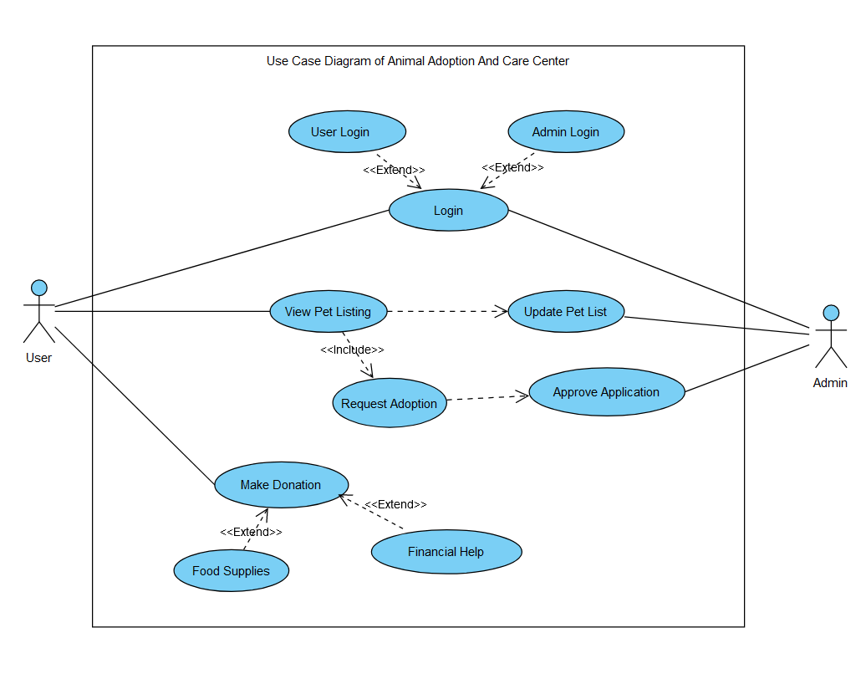

**4 Input/Output Screens :**

**4.1 Sign In page:**

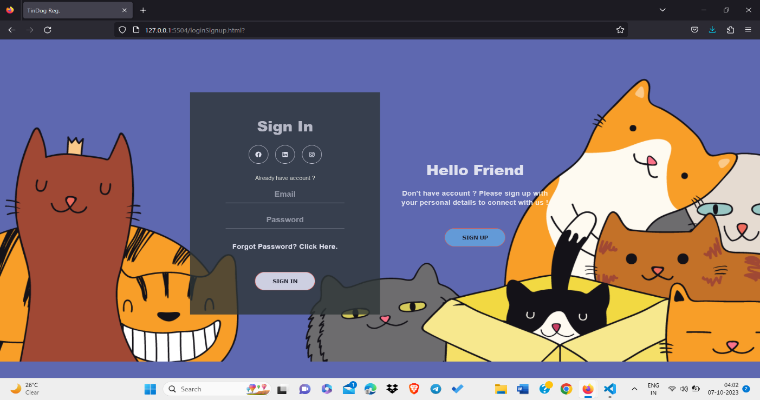

**4.2 Sign Up page :**

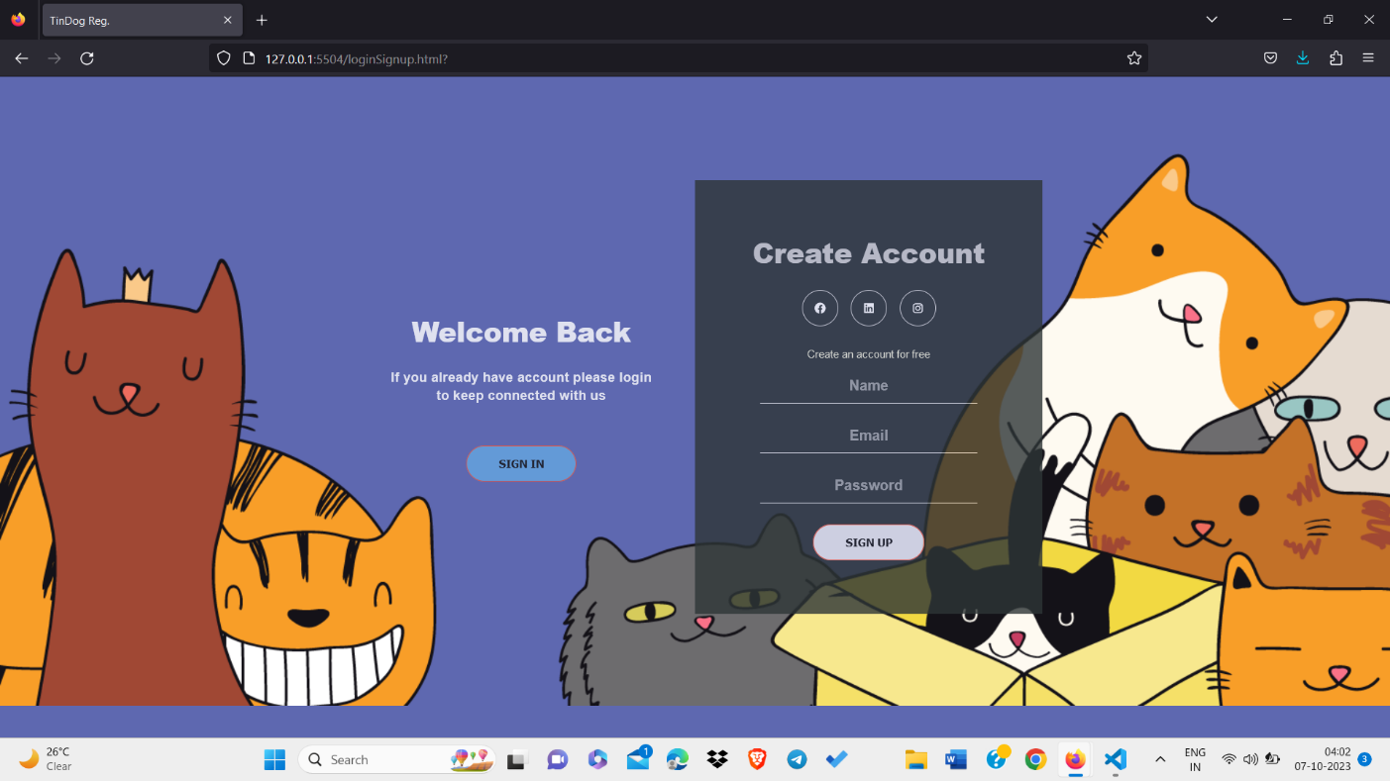

**4.3 Home Page :**

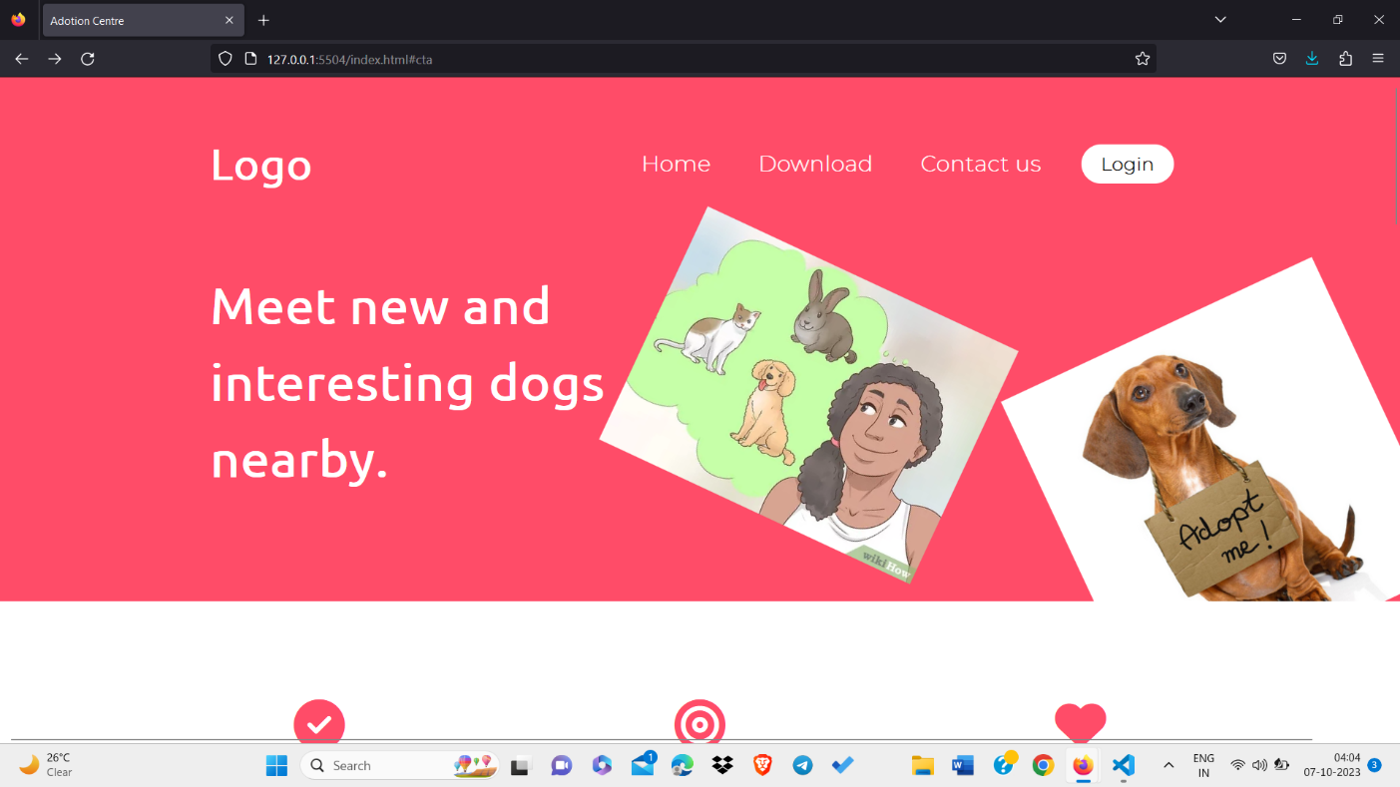

**Broadcast :**

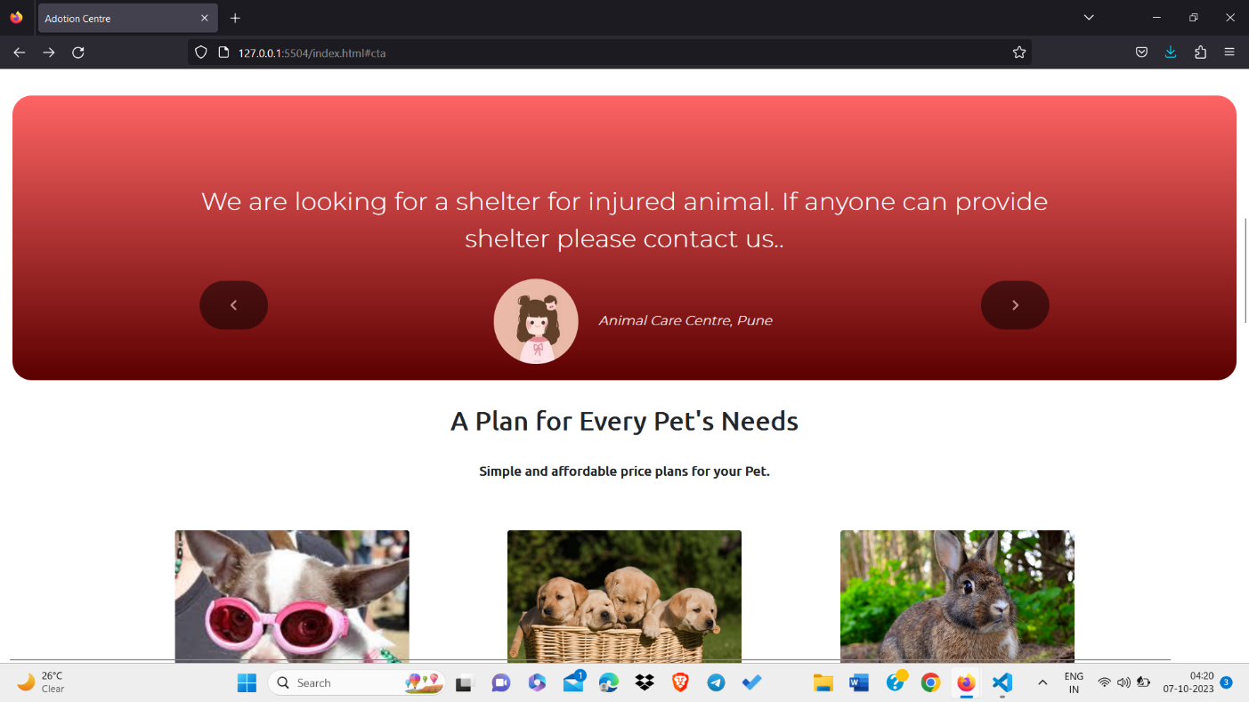

**Adoption Window :**

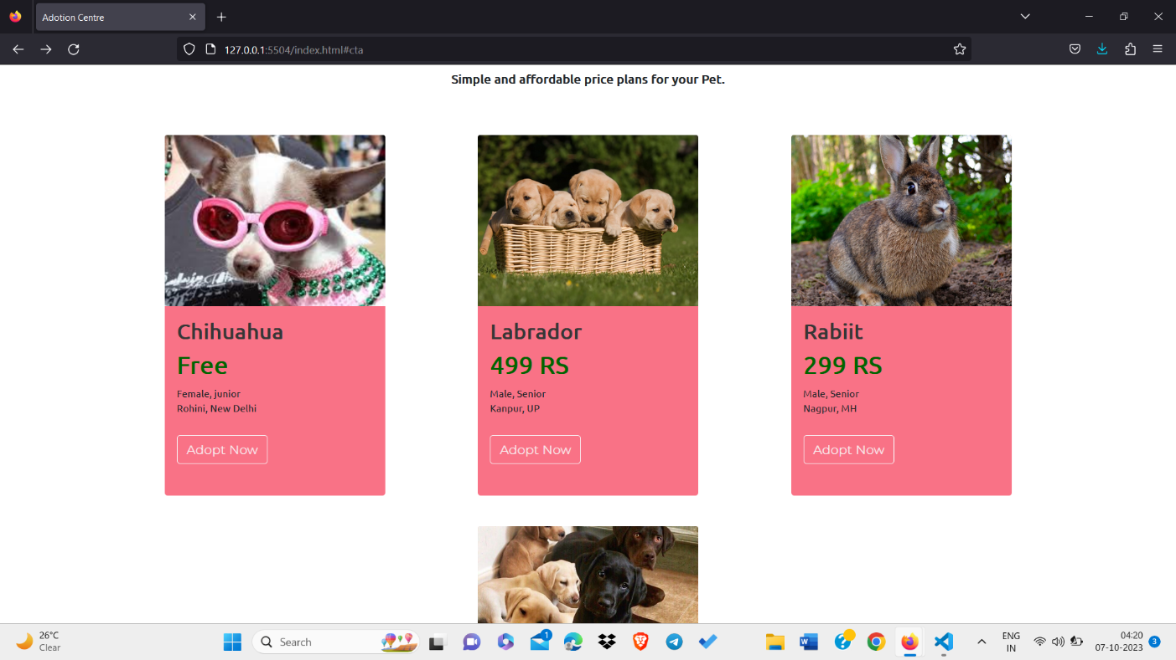

**Contact :**

